Choosing the Right Statistical Test: A Decision Tree Approach
Choosing the Right Statistical Test: A Decision Tree Approach
Statistical tests are analytical tools that help researchers or data professionals evaluate the relevance of hypotheses or analysis results on their data. They help for instance, determine if there exist relationships or differences between variables or groups in a data population.
For professionals without a profound statistics background, choosing the right statistical test to perform on their data might sometimes not be a straightforward task. This article provides a decision tree-based guide aimed at helping them navigate the problem of choosing the right test depending on the data and problem they are facing, and the hypothesis to be tested.
Before jumping into this guide, it is worth highlighting one classification criterion under which statistical tests are categorized:
- Parametric tests are utilized when the data are assumed to follow a specific distribution, usually a normal distribution. Examples of parametric tests are the t-test, ANOVA (Analysis of Variance), and regression analysis.
- Non-parametric tests are useful when no assumptions are made about the data distribution, when the data do not meet the assumptions needed for parametric tests, such as normality or homogeneity of variance, or when the data are ordinal. They are also more reliable than parametric tests when data samples have a small size. Examples of non-parametric tests include the Mann-Whitney U test, Kruskal-Wallis test, and Wilcoxon signed-rank test.
A Decision Tree Approach
The following decision tree diagram covers the statistical tests used in the vast majority of use cases, and the key criteria guiding to choosing each of them, from left to right. Ask and answer yourself the questions in the boxes to be guided to the right test for your problem and data.
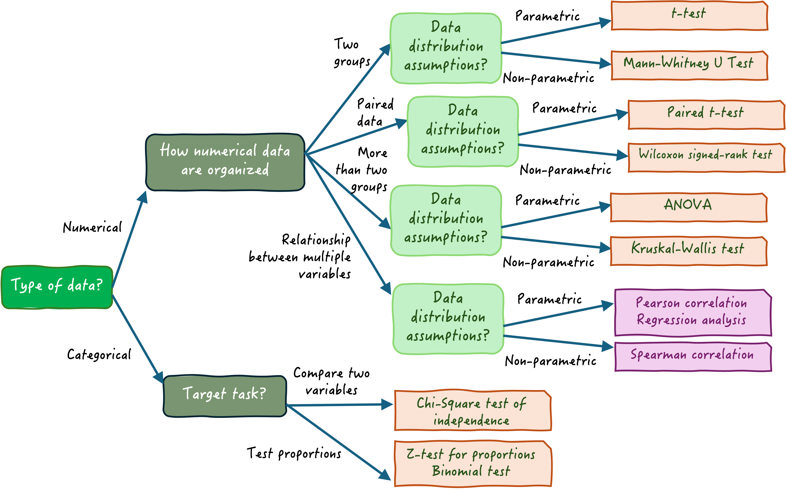
A decision tree for choosing the right statistical test

A few specific example use cases and observations are provided below to help you better understand the nuances and terminology used in the above diagram:
T-Test
- Example: Compare average test scores of two different high-school classes.
- Justification: The t-test evaluates if there is a statistically significant difference between the means of two independent groups.
Paired T-Test
- Example: Measure glucose levels before and after treatment in the same group of patients.
- Justification: The paired t-test is used for “paired data,” that is, two groups of related data where the same subjects are measured twice (typically ‘before’ and ‘after’), enabling comparison of the means of two related groups.
ANOVA (Analysis of Variance)
- Example: Analyze the exam scores of students from three different classrooms.
- Justification: ANOVA is a parametric test that compares the means of three or more independent groups to check if at least one group’s mean is different from the others.
Chi-Squared Test
- Example: Explore the relationship between gender and preference for a product (e.g., male vs. female customers having differentiated product interests).
- Justification: The chi-squared test assesses whether there is a significant association between categorical variables, to assess if two distributions of categorical variables differ from each other.
Spearman’s Rank Correlation
- Example: Investigate the relationship between students’ performance rankings in math and science.
- Justification: This non-parametric test measures the strength and direction of association between two ranked variables, being useful when data does not meet the assumption of following a normal distribution.
Regression Analysis
- Example: Predict sales based on advertising expenditure.
- Justification: Regression analysis assesses the relationship between a dependent variable (sales) and one or more independent variables (advertising), allowing for predictions based on those relationships.

Mann-Whitney U Test
- Example: Compare customer satisfaction ratings between two different stores.
- Justification: This is a non-parametric test useful when we want to compare two independent groups of numerical data that do not necessarily follow a normal distribution.
Wilcoxon Signed-Rank Test
- Example: Evaluating the effectiveness of a new medication by comparing patients’ pain levels before and after treatment.
- Justification: Wilcoxon signed-rank test is a non-parametric test used for paired data, assessing whether the ranks of differences between two related groups are significant.
Z-Test
- Example: Compare the proportion of customers who prefer Brand X over Brand Y based on two independent surveys, determining if the difference in preferences is statistically significant.
- Justification: This test is used for “testing proportions,” consisting of comparing the proportions of two independent samples to check if the difference is greater than what could be expected by chance.

